**Digital Forensics Lab Report: 4**

Date: 17-08-2022

| Name: | Vedant H. Patel |
| --- | --- |
| Roll No: | 19BCP138 |
| Subject Code: | 20CP411P |
| Subject Name: | Digital Forensics Lab |

**Aim/Purpose:** Perform Steganography using Stegano tools

**Tool Names:** Google image search, Tineye image search, YouTube data viewer, Foto forensic, Forensically, Pic2map, Suncalc, Wikimapia, Exif Data Viewer, Jeffrey exif viewer, Exiftool, Metagoofil, YouTube metadata.

**Task 1: Fotoforensics**

**Steps:**

1. Open FotoForensics.
2. Select “Image URL” if you want to insert the image url or “Upload File” if you want to select the file from your local machine.
3. Then Click on upload url and upload image.
4. Then you get all data regarding images like ICC+, metadata, etc.

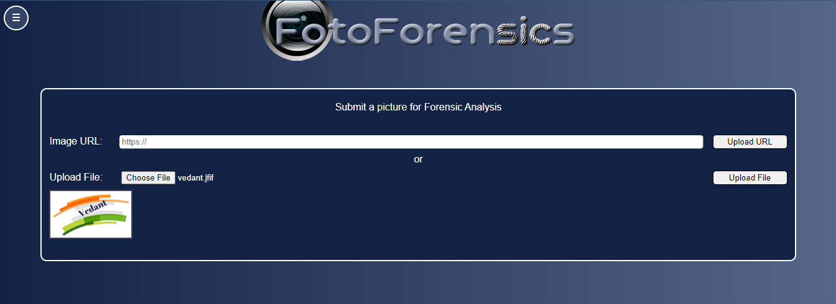

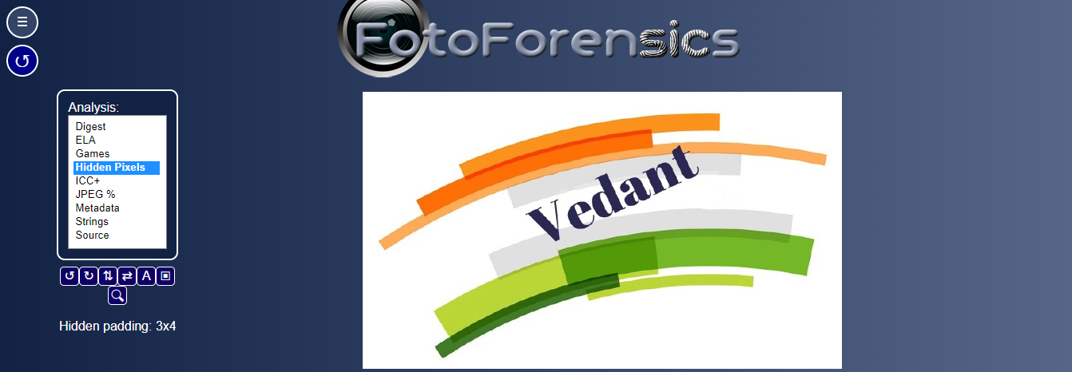

**ICC:**

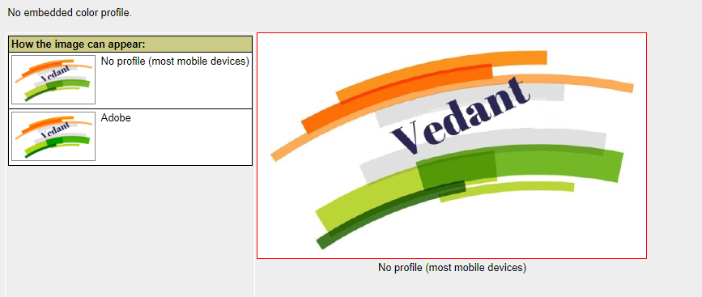

**JPEG:**

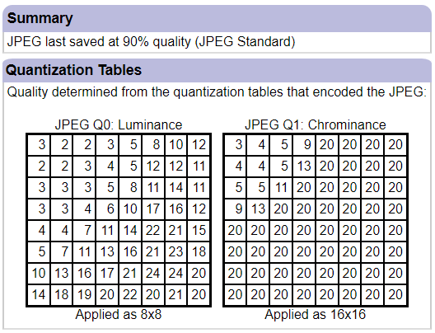

**MetaData:**

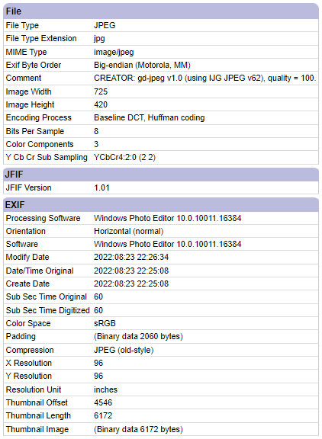

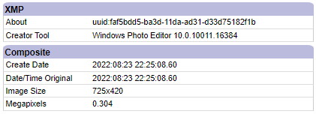

**Analysis:**

1. We can analyse the image by Hidden pixels or ELA. By using those modules we can easily get all information about the raw structure.

**Task 2: TinEye**

**Steps:**

1. Open <https://tineye.com/>
2. Then Select the Upload button and select the image from the local machine.
3. Then press enter click
4. After you get all related results

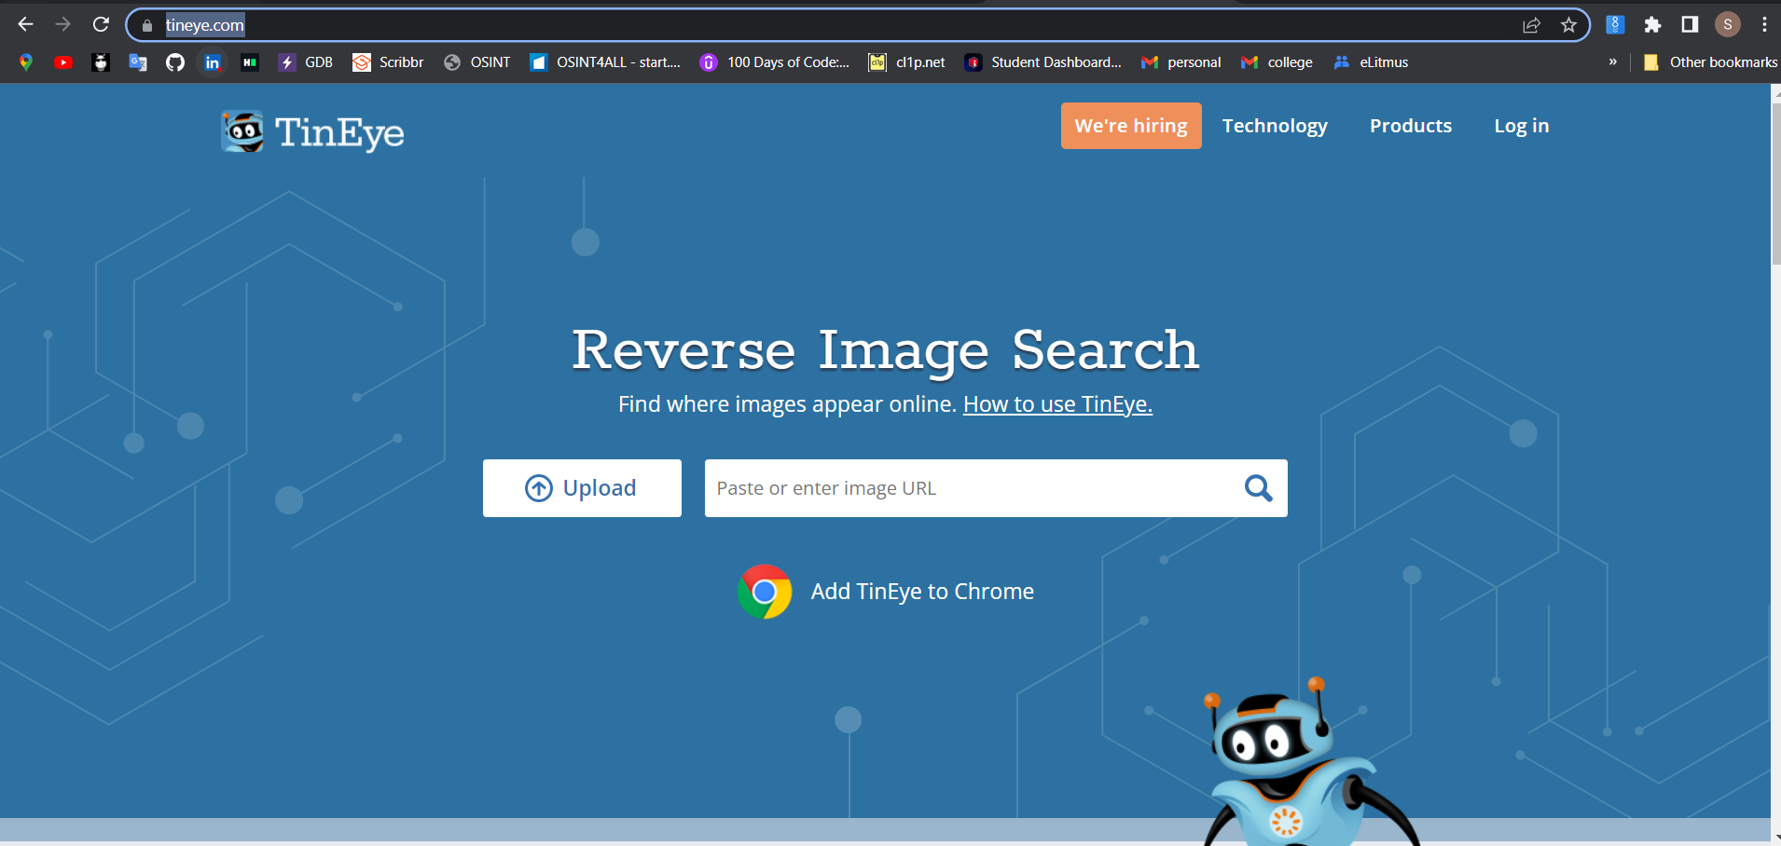

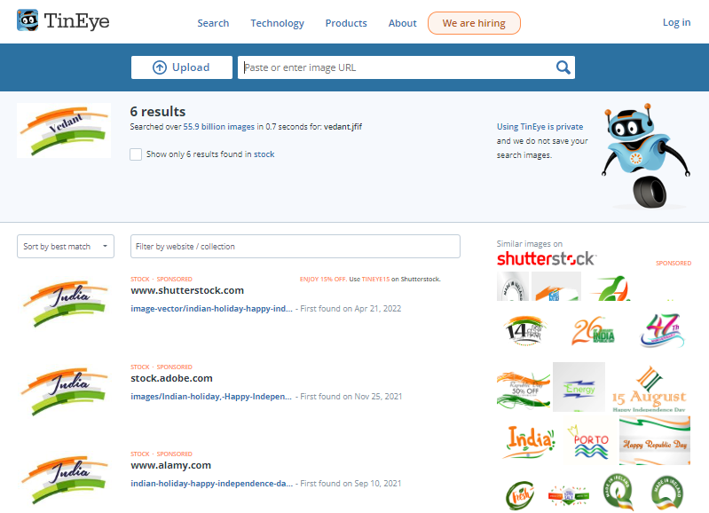

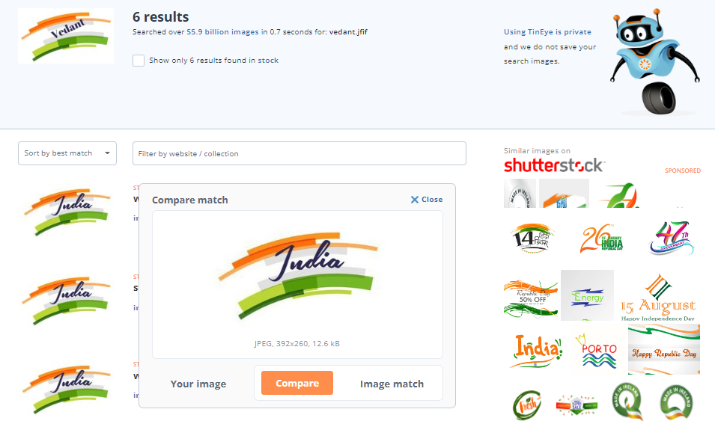

**Analysis:**

1. It is very useful when you have random images but you don’t know and you get similar results so you will get to know about the images
2. It has features of comparing the input image and finding results so you can easily compare both images.

**Tool 3: Pic2Map**

**Steps:**

1. Open <https://www.pic2map.com/>
2. Upload the images of geographical location or you can select the images randomly too.
3. Then you will get all images and geographical information about that image's place.

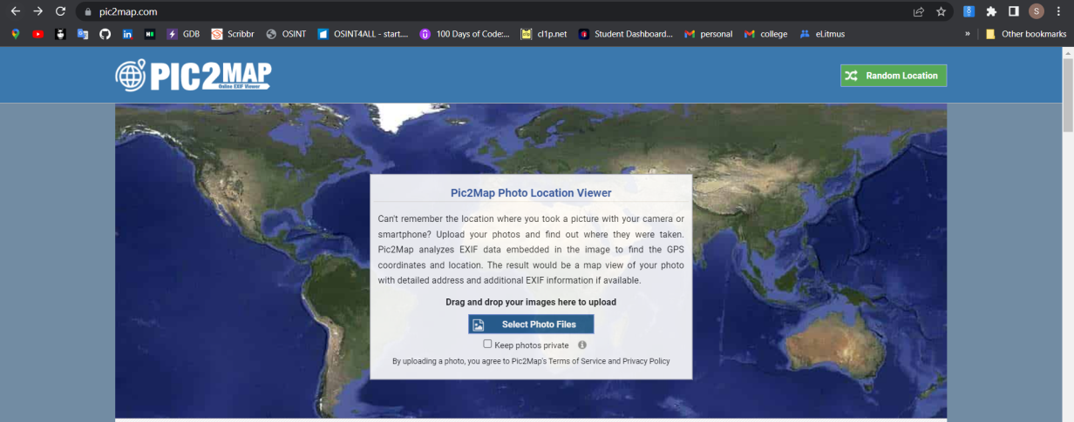

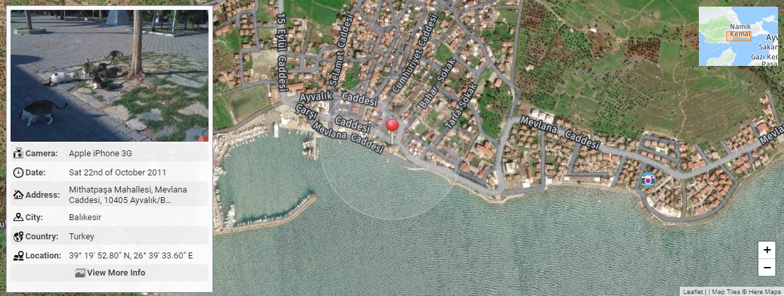

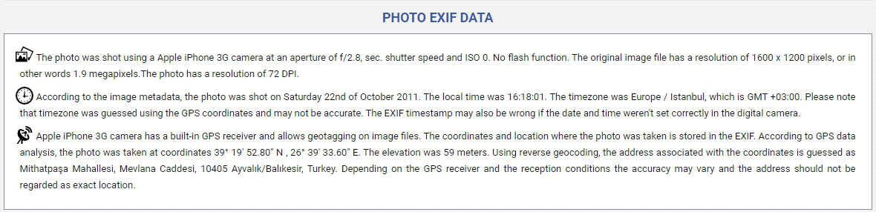

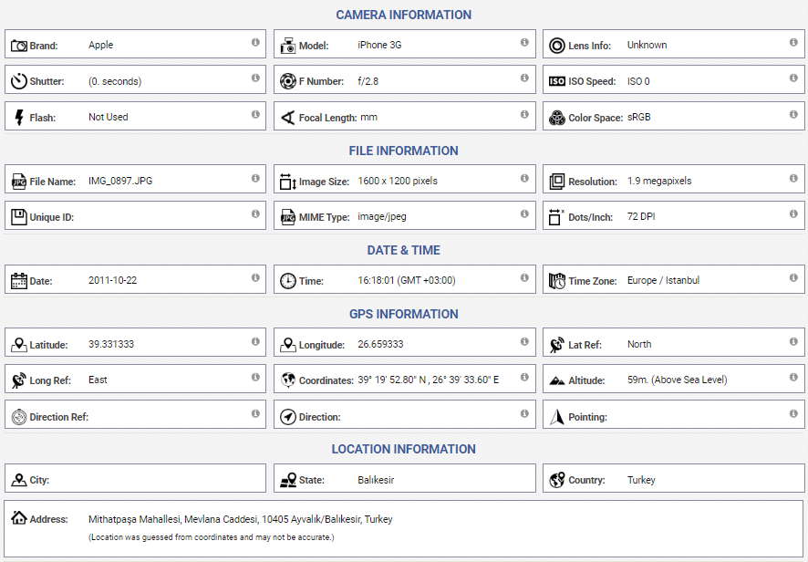

**Analysis:**

We can get lots of information about any geographical location by its photo and also you will find any random place by its photos and you will get the information about it.

**Tool 4: Google image search**

**Steps:**

1. Open <https://images.google.com/>
2. Click on the search bar and type whatever you want or you can also speak for searching.
3. Then you will get all image results.
4. By selecting any images you will get those images also you can save or download them and copy them or their url.

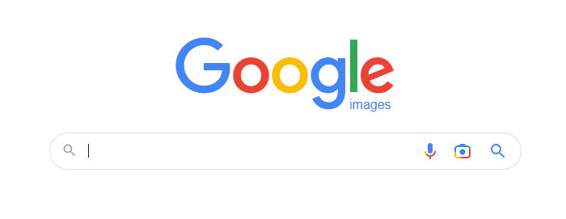

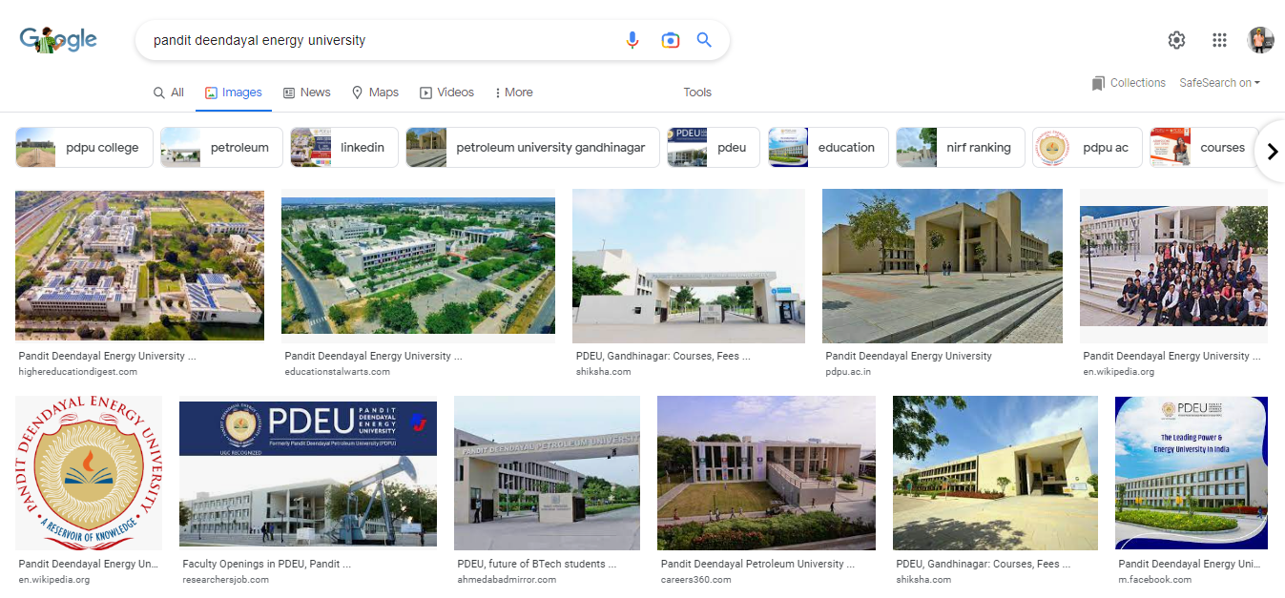

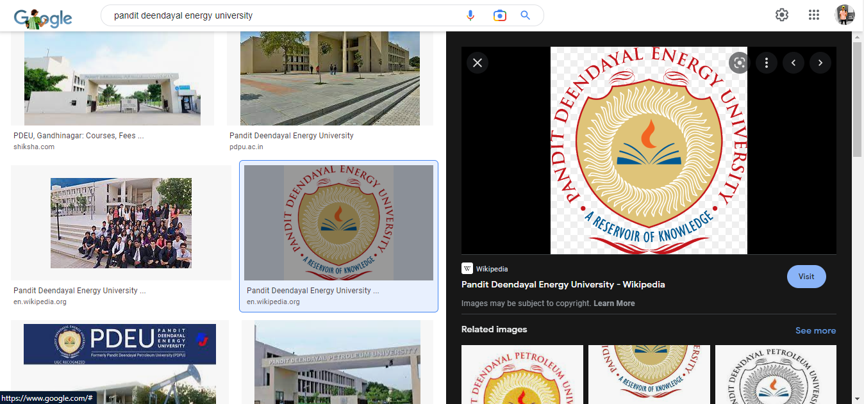

**Analysis:**

Very easy to access and you can also find lots of images shortly.

**Tool 5: YouTube metadata**

**Steps:**

1. Open <https://mattw.io/youtube-metadata/>
2. Click or search bar and copy the youtube link of that video which you want forensic.
3. Press on “submit”
4. Then you will get all image results, scripts codes or written information.

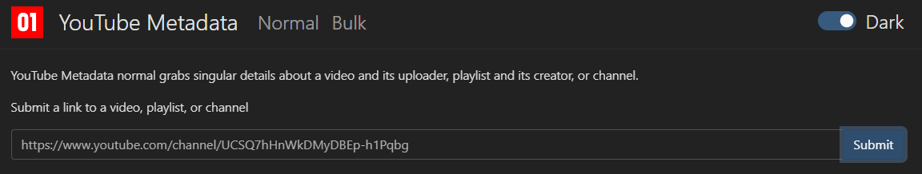

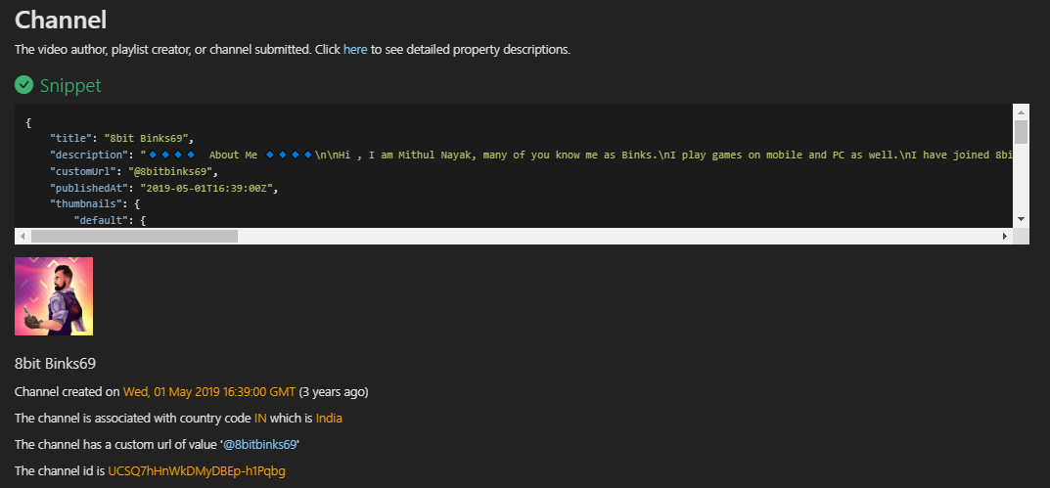

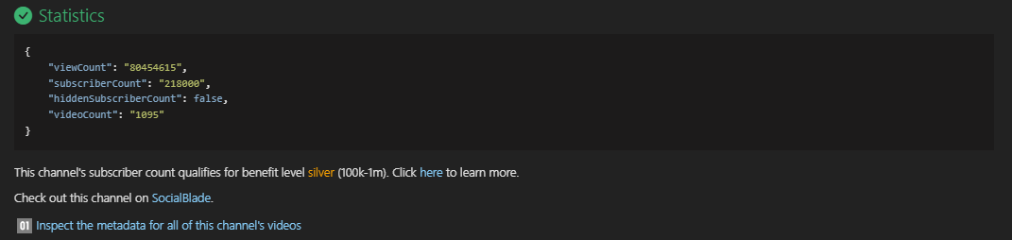

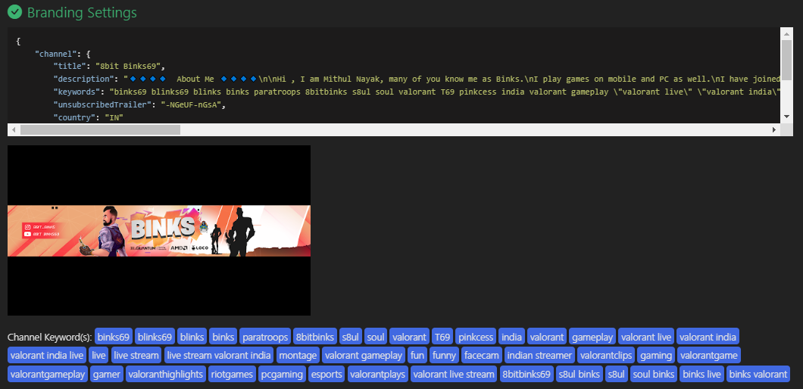

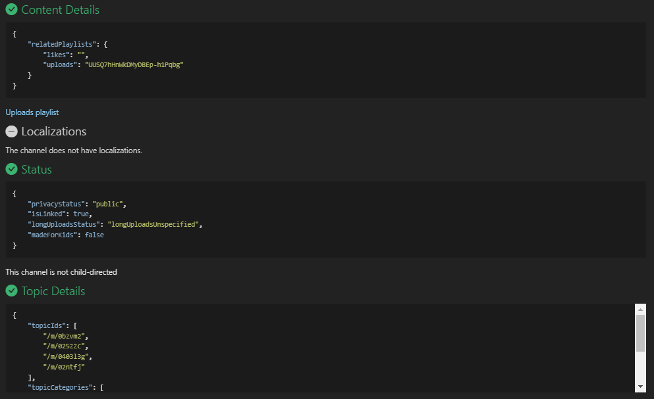

**Analysis:**

With a single video link you can easily fetch all information and script code of that video web page when the video gets released who created a video in which language video is available and all.

You can also get the channel owner and channel details like when the channel is created or other video links or other playlist details.

Also, you can watch statistics of the channel like subscriber count and video count, and so on.